# Lab: Object Composition

Problems for exercises and homework for the ["JavaScript Applications" course @ SoftUni](https://softuni.bg/courses/js-applications).

Submit your solutions in the SoftUni judge system at <https://judge.softuni.bg/Contests/1545>.

## Heroes

Create a function **returns** an **object** with 2 methods (**mage** and **fighter**). This object should be able to **create** heroes (fighters and mages). Every hero has a **state**.

* Fighters have **name**, **health = 100** and **stamina = 100** and every fighter can fight. When he **fights** his **stamina** **decreases** by **1** and the following message is **printed** on the console:

**`${fighter's name} slashes at the foe!`**

* Mages also have state (**name**, **health = 100** and **mana = 100**). Every mage can **cast** **spells**. When a spell is casted the mage's **mana** **decreases** by **1** and the following message is **printed** on the console:

**`${mage's name} cast ${spell}`**

### Note:

For more information check the examples below.

|  |  |
| --- | --- |
| Input | Output |
| let create = solve();  const scorcher = create.mage("Scorcher");  scorcher.cast("fireball")  scorcher.cast("thunder")  scorcher.cast("light")  const scorcher2 = create.fighter("Scorcher 2");  scorcher2.fight()  console.log(scorcher2.stamina);  console.log(scorcher.mana); | **Scorcher cast fireball**  **Scorcher cast thunder**  **Scorcher cast light**  **Scorcher 2 slashes at the foe!**  **99**  **97** |

### Hints:

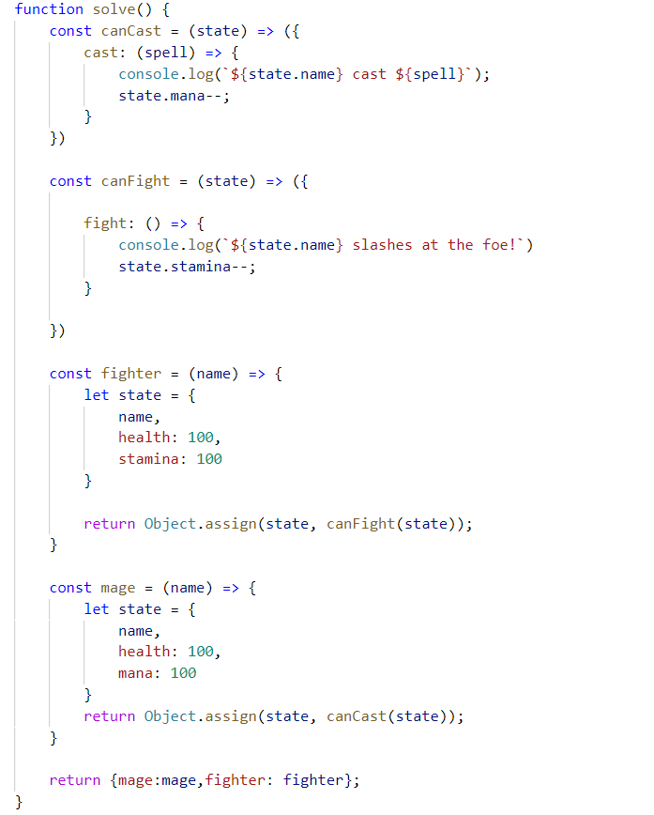

## Order Rectangles

You will be passed a few pairs of **widths** and **heights** of rectangles, create **objects** to represent the rectangles. The objects should additionally have two functions area - that returns the area of the rectangle and compareTo - that compares the current rectangle with another and produces a number signifying if the current rectangle is **smaller** (negative number), **equal** (0) or **larger** (positive number) than the other rectangle.

### Input

The input will come as an **array of arrays** - every nested array will contain exactly 2 numbers the width and the height of the rectangle.

### Output

The output must consist of an array of **rectangles** (objects) sorted by their area in **descending** order as a **first** criteria and by their width in **descending** order as a **second** criteria.

### Examples

|  |  |
| --- | --- |
| Input | Output |
| [[10,5],[5,12]] | [{width:5, height:12, area:function(), compareTo:function(other)},  {width:10, height:5, area:funciton(),compareTo:function(other)}] |
| [[10,5], [3,20], [5,12]] | [{width:5, height:12, area:function(), compareTo:function(other)},  {width:3, height:20, area:funciton(),compareTo:function(other)},  {width:10, height:5, area:funciton(),compareTo:function(other)}]] |

## List Processor

Using a closure, create an inner object to process list commands. The commands supported should be the following:

* **add** **<string>** - adds the following string in an inner collection.
* **remove** **<string>** - removes all occurrences of the supplied **<string>** from the inner collection.
* **print** - prints all elements of the inner collection joined by **","**.

### Input

The **input** will come as an **array of strings** - each string represents a **command** to be executed from the command execution engine.

### Output

For every print command - you should print on the console the inner collection joined by **","**

### Examples

|  |  |
| --- | --- |
| Input | Output |
| [**'add hello'**, **'add again'**, **'remove hello'**, **'add again'**, **'print'**] | **again,again** |
| [**'add pesho'**, **'add george'**, **'add peter'**, **'remove peter'**,**'print'**] | pesho, george |

## Object Factory

Write a function that can **compose** **objects**. You will **receive** a **string** and your goal is to create a **new** **object** with all the **unique** properties you were **given**. For more information check the examples below.

### Input

The **input** will come as a **string**, which represents an array of objects.

### Output

You should print the **newly** **created** **object**.

### Examples

|  |  |
| --- | --- |
| Input | Output |
| **`[{"canMove": true},{"canMove":true, "doors": 4},{"capacity": 5}]`** | **{ canMove: true, doors: 4, capacity: 5 }** |
| **`[{"canFly": true},{"canMove":true, "doors": 4},{"capacity": 255},{"canFly":true, "canLand": true}]`** | { canFly: true, canMove: true, doors: 4, capacity: 255, canLand: true } |

## Cars

Write a closure that can create and modify objects. All created objects should be **kept** and be accessible by **name**. You should support the following functionality:

* create <name> - creates an object with the supplied **<name>**
* create <name> inherits <parentName> - creates an object with the given <name>, that inherits from the parent object with the <parentName>
* set <name> <key> <value> - sets the property with key equal to <key> to <value> in the object with the supplied <name>.
* print <name> - prints the object with the supplied <name> in the format "<key1>:<value1>,<key2>:<value2>…" - the printing should also print all **inherited properties** from parent objects. Inherited properties should come after own properties.

### Input

The **input** will come as an **array of strings** - each string represents a **command** to be executed from your closure.

### Output

For every print command - you should print on the console all properties of the object in the above mentioned format.

### Constraints

* **All commands will always be valid, there will be no nonexistent or incorrect input.**

### Examples

|  |  |
| --- | --- |
| Input | Output |
| [**'create c1'**,  **'create c2 inherit c1'**,  **'set c1 color red'**,  **'set c2 model new'**,  **'print c1'**,  **'print c2'**] | **color:red**  **model:new, color:red** |

## Sum

Create a function which returns an object that can modify the DOM. The returned object should support the following functionality:

* init(selector1, selector2, resultSelector) - initializes the object to work with the elements corresponding to the supplied selectors.
* add() - **adds** the numerical value of the element corresponding to selector1 to the numerical value of the element corresponding to selector2 and then writes the result in the element corresponding to **resultSelector**
* subtract() - **subtracts** the numerical value of the element corresponding to selector2 from the numerical value of the element corresponding to selector1 and then writes the result in the element corresponding to resultSelector

### Input

There will be no input your function must only provide an object.

### Output

Your function should return an object that meets the specified requirements.

### Constraints

* **All commands will always be valid, there will be no nonexistent or incorrect input.**
* **All selectors will point to single textbox elements.**

### HTML

You are given the following HTML for testing purposes:

|  |
| --- |
| sum.html |
| <!DOCTYPE **html**> <**html lang="en"**> <**head**>  <**meta charset="UTF-8"**>  <**title**>Title</**title**> </**head**> <**body**> <**input type="text" id="num1"** /> <**input type="text" id="num2"** /> <**input type="text" id="result" readonly** /> <**br**> <**button id="sumButton"**>  Sum</**button**> <**button id="subtractButton"**>  Subtract</**button**> </**body**> </**html**> |